Protocol # | Description | Purpose | Reqt/Spec
  Author
Emp004 | Add new Users | To verify  1.Able to create new user  2. Validations of mandatory fields.

Prerequisites | - Standard System Configuration  - User must be logged In to the web interface.  - The user must have administrative privileges.  - At least one employee should be available for the selected location.  - At least one group should be available for the selected location.
Procedure | - Login to the web interface.  - Click on Administration link from the top right menu.  - Click on Users link  ER 1 – User records Screen is displayed.  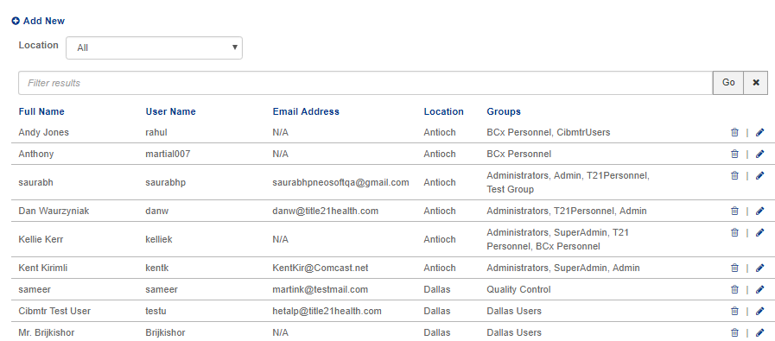  - Click on location drop-down and select the specific location (for eg. Dallas).  ER 2 – Only Users of selected location are displayed.  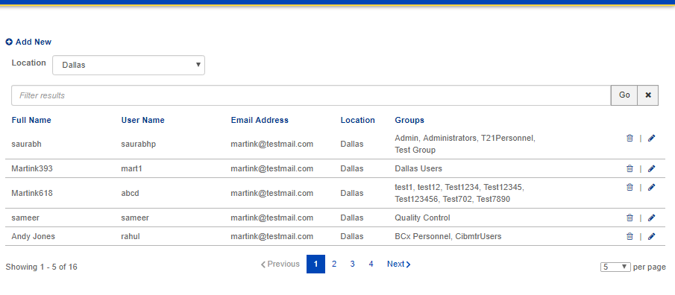  - Enter the invalid data in user’s field and click on GO button.  ER 3 – It should show validation messages as “No User Found”.  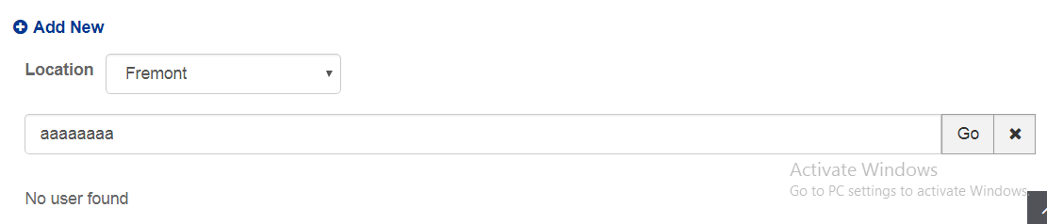  - Click on “Add New” button.  ER 4 – Add new user popup screen appears.  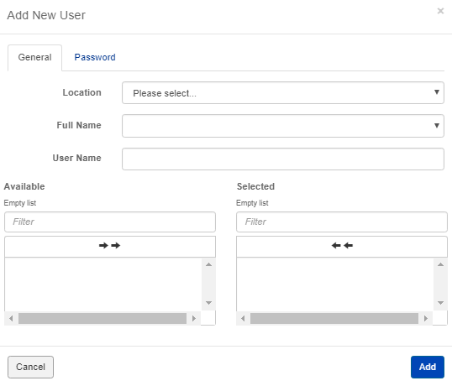  - Click on Add Button  ER 5- It displays validation messages as “Location is required” “Full Name is required” “User Name is required” “Please select at least one group”.  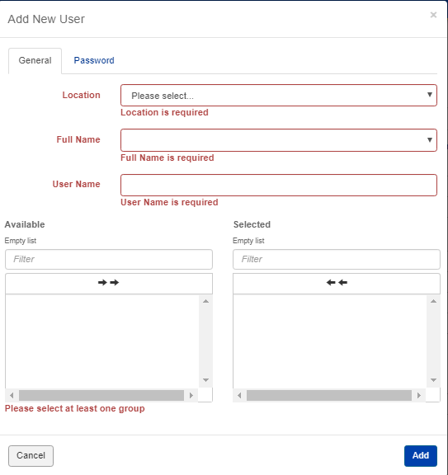  - Select one location.(for eg: Houston)  ER 6- “list of employees” in full name field and “groups” associated with that location should get listed.  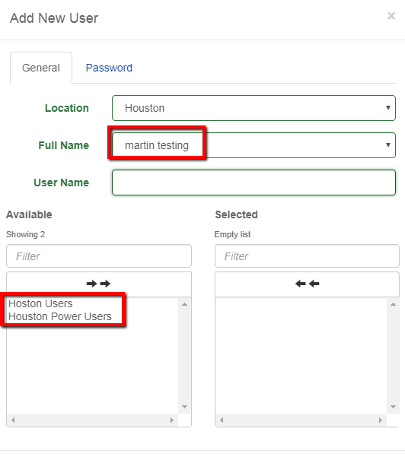  - Select Location whose all employees have already been assigned a user ID  ER 7 – It displayed validation message as “All employees have already been assigned a user ID”.  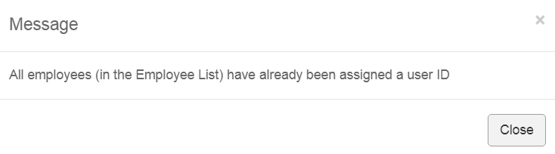  - Enter already existing username in username field.  ER 8 – A validation message “Full Name already exists” and EmployeeID Already Exists” are displayed.  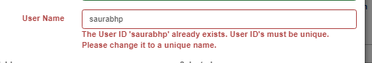  - Select one employee  - Enter username  - Add one group by clicking on the arrow.  - Click on add button.  ER 9 – It should Navigate to “Password Tab”.  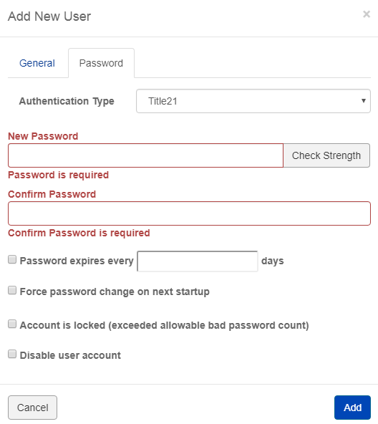  - Click on Add Button without entering a “new password” and “confirm password”.  ER 10 – It should display validation messages as “Password is required”, “Confirm Password is required”.  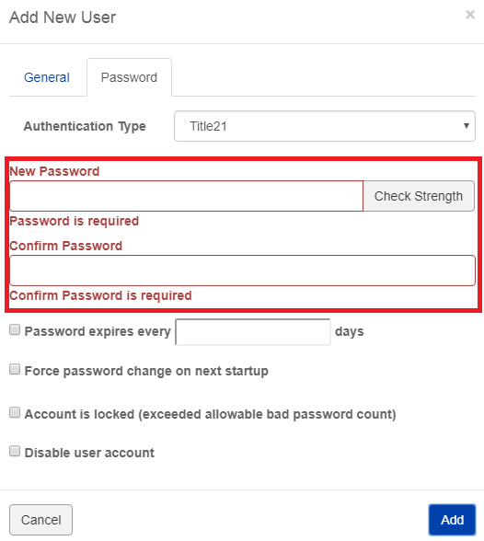  - Select authentication type as Title21.  - Enter password less than 10 characters.  - Click on check strength.  ER 11 – It should display validation messages as “password contain at least 10 characters”.  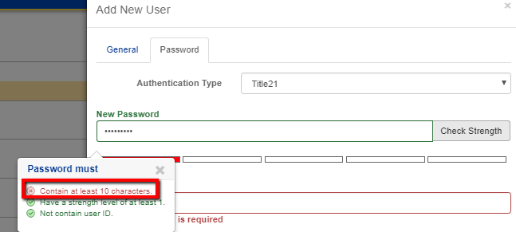  - Enter password contains user Id.  - Click on add button  ER 12 – It should display validation messages as “Password cannot contain User Id ”.  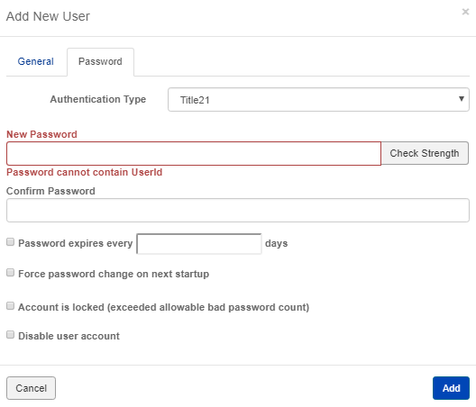  - Enter valid password  - Enter invalid data in confirm password field.  ER 13 – It should display validation messages as “Password does not match”.  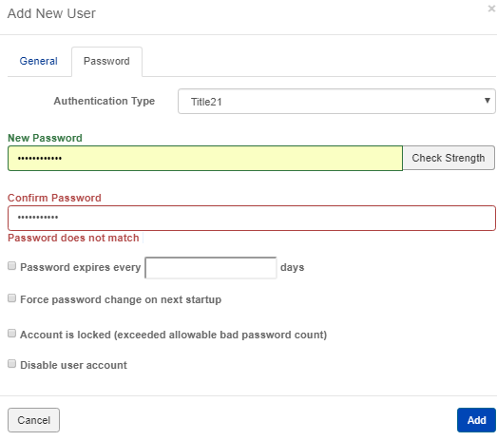  - Enter valid password and confirm password  - Click on add button.  ER 14 – A message confirming the user is successfully added is displayed.  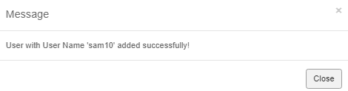  - Go to user list screen  - Click on search filter and enter the created user’s name  - Click on Go butto  ER 15 – User Record as per search is displayed .  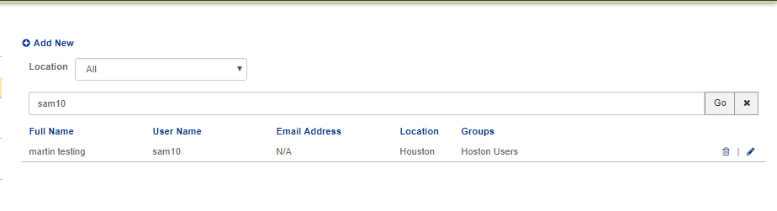
Pass/Fail | Pass:  Fail: | Type of Execution |  | Date:
Pass/Fail | Pass:  Fail: | Automation: | Manual: | Date:
 | Date of Execution:
Notes/Deviations
Additional Remarks in case of Manual Execution
Name of Tester(if Manual)
Test Case Review/Approval | Signature of  Reviewer/Approver: |  |  | Date of Approval:

